**Assignment no 2**

**Messaging App**

**Outputs**

Menu:

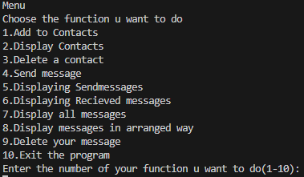

Communication:

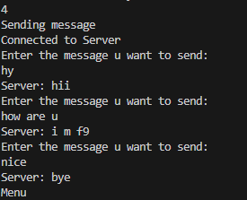

Display sendmessages:

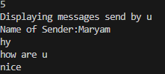

Display received messages:

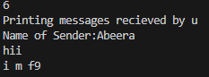

Display all conversation:

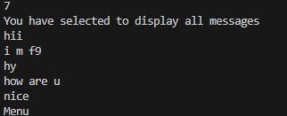

Display messages in a sorted way:

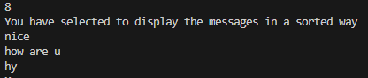

Deleting messages:

